YHWH gives the sun for light by day
Let's look at the following verses from the RSV:
Jer 31:35 Thus says Yahuwah, who gives the sun for light by day and the fixed order of the moon and the stars for light by night, who stirs up the sea so that its waves roar—Yahuwah of hosts is his name:
Jer 31:36 "If this fixed order departs from before me, says Yahuwah, then shall the descendants of Israel cease from being a nation before me for ever."

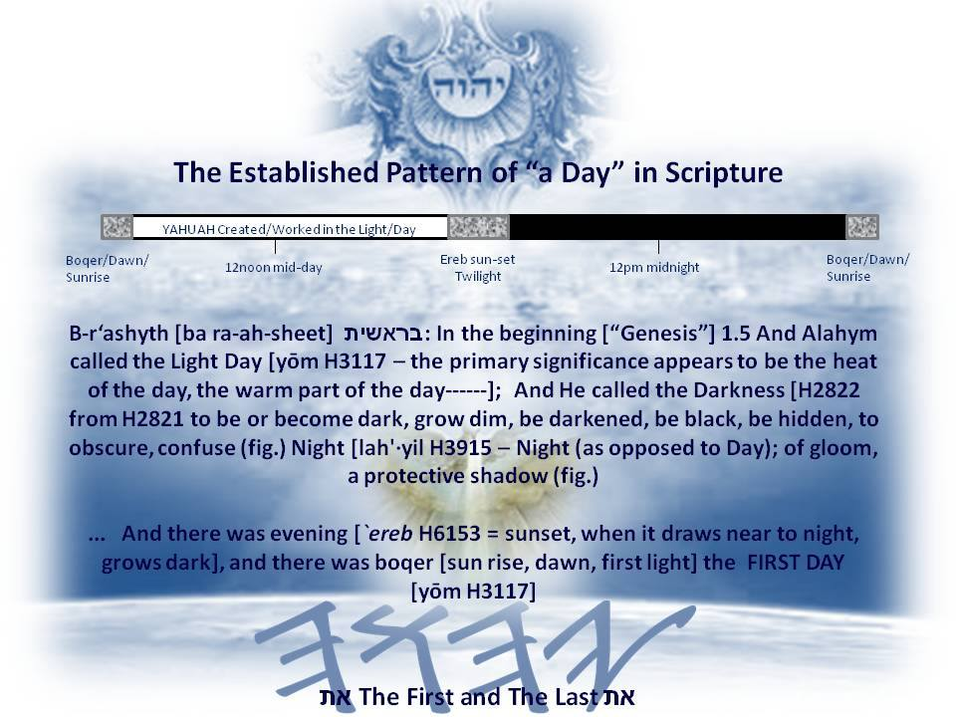
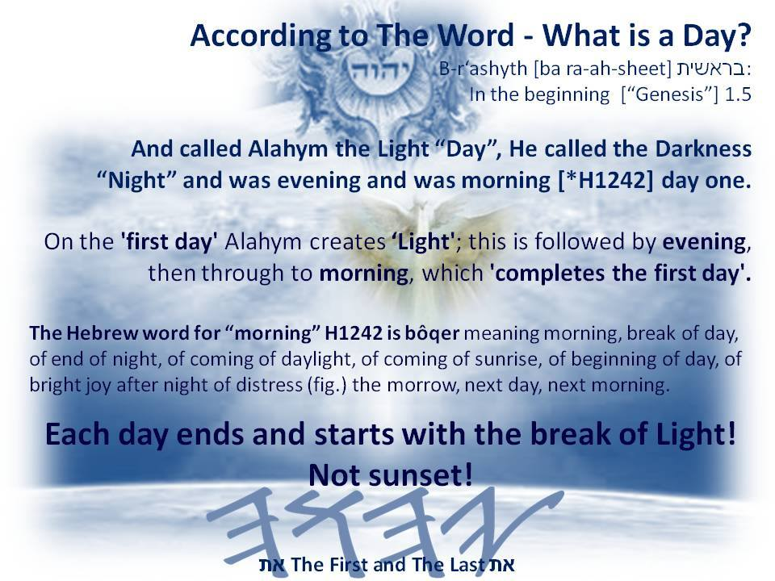

http://thepathtoyahuah.com/wp-content/uploads/2016/07/09-Shabbath-Lesson-on-the-Calendar-Part-1.pdf These are all the notes that are used in the Sabbath Lessons on YouTube and other Live Lessons covered on the Sabbath. We have also included a Sabbath Study curriculum for children including home schooling. Please feel free to use these notes to follow along, or to study on your own time. We hope they can be a resourceful tool in your studies.
Take note of the Wednesday n the 4#day

