
CHODESH 1亞筆月2017年1月月
Sun in 4th Gate 門

Spring
DAY 1 天  Yom RISHON | DAY 2天  Yom SHENI |  |   DAY 3天  Yom SHLISHI |  | DAY 4天  Yom ARBA |  | DAY 5天  Yom CHAMISHI | DAY 6天  Yom SHISHI | DAY 7天  Yom SHABBAT
 |  |  | 春分EQUINOX  Yom 364 天  Spring Marker |  | 1 新年亞筆1日 3/21 SHUVAH HA’SHANAH  ROSH CHODESHIM  MEMORIAL- NOAH  Land visible |  | 2 | 3 | 4 3/24  安息日  SHABBAT
5 | 6 |  | 7 |  | 8 |  | 9 | 10 挑選羔羊  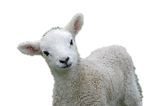  SELECT LAMB | 11 3/31  SHABBAT
12 | 13 |  | 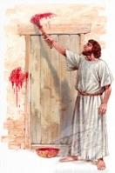  14 | 逾越 4 4/3  PASSOVER | 15  無酵餅節7天 | 死/埋葬 4/4  Messiah  Dies @  Evening  Oblation | 16  1st Day & Night in the grave  第1天及第2夜 | 17  2nd Day & Night in the grave  第2天及第3夜 | 18 4/7  SHABBAT  3rd Day 第3天復活RESURRECTION  馬太12:40
19  RESURRECTION復活  Before sunrise日出前 | 20  Holy 召集日Convocation  End Unleavened at sundown | 4/9 | 21 |  | 22 |  | 23 | 24 | 25 4/14  SHABBAT
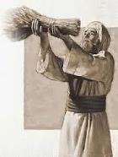  26 4/15 FIRST FRUITS  Barley  大麥初熟果  Note: The Vernal Equinox falls primarily on March 20- but, can fall as early as the 19th and as late and the 21st  FIRST FRUITS  Barley 初熟果節 | 27  OMER 2 |  | 28  OMER 3 |  | 29  OMER 4 |  | 30 4/19  OMER 5

