Prof. Rachel Elior explains how the sages invented

Judaism as we know it.

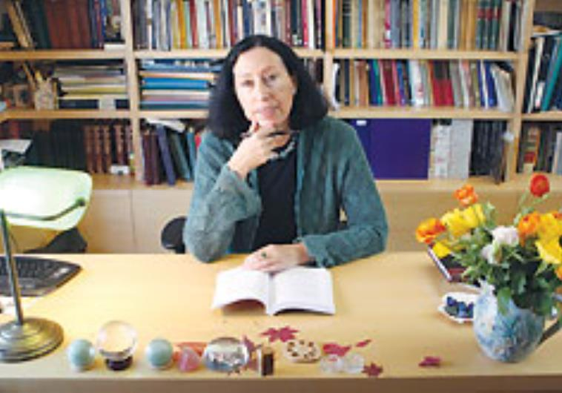

(photo credit:Ariel Jerozolimski)
Share on Facebook Share on Twitter
The scene could be out of the Haggada - a group of rabbis sitting on the floor in a circle through the night, probably reclining on pillows, scrolls scattered about them, engaging in heated disputation until the pale light outside signals that a new day is upon them. The fact that this particular gathering, mentioned in the Talmud, is held in an attic (aliyat gag) might suggest to a modern reader that there is something clandestine about it, perhaps a desire to take distance from Roman ears or even from the surrounding Jewish population. Clandestine or not, this meeting, and all the similar gatherings that preceded and followed, contained the seeds of revolution - the radical restructuring of Jewish religious thought and practice that followed the destruction of the Temple in 70 CE. According to Prof. Rachel Elior of the Hebrew University of Jerusalem, the rabbis were involved in nothing less than "a reinvention of Judaism... They were closing an old world based on prophecy and angelic revelation and opening the sacred canon to human reinterpretation." A glimpse into that intellectual ferment is provided in the brief depiction in the talmudic tractate Shabbat (13b) of the rabbinic gathering, perhaps in Yavne - which had become the major center of Jewish learning after the destruction of Jerusalem. "That man should be remembered with favor," the passage says in reference to one of the participants in the meeting, "his name being Hanania son of Hezekiah, for if it were not for him the Book of Ezekiel would have been suppressed and withdrawn as its teachings contradict those of the Torah. What did he do? They brought him jugs of oil [for lamps] and he sat in the attic and expounded upon the texts [through the night]." What Hanania and his colleagues were engaged in was a culling of all the Hebrew religious texts composed until that time. The works they would choose from this library would constitute the Jewish canon which henceforth would be the only texts deemed to have divine authority. In the end, a consensus formed around 24 works, including the five books of the Pentateuch, which together would make up the Bible. But what of the works excluded from the canon? Many were of comparable literary and religious quality to those chosen, says Elior, a professor of Jewish philosophy and Jewish mystical thought. "To many of the Jews of the first millennium BCE, all the texts had been equally holy," she says. "The [excluded] Book of Enoch or Book of Jubilees were certainly not considered less sacred than the [canonical] Book of Judges or Esther or Daniel." Yet the excluded texts - close to a dozen major works - were not just abandoned but excised as if they were a malignant growth. "Whoever reads them," declared Rabbi Akiva, one of the foremost sages involved in the process, "will have no place in the world to come." Left to die, some of the expelled texts were rescued and adopted by another religion. Newborn Christianity, which regarded itself as the successor of Judaism, incorporated these texts into its own corpus of holy works along with the Old Testament, as the Hebrew Bible came to be called. In time, Jewish scholars would rediscover the repudiated texts of their ancestors in Greek, Ethiopian (Geez), Syriac, Armenian and Slavic church translations. These writings, known as Apocrypha ("hidden scriptures" in Latin) would never be reincorporated into the Jewish library but would remain for scholars to puzzle over as they tried to understand by what criteria the texts had been rejected. HALF A century ago another lost library with a mystery attached surfaced on the shores of the Dead Sea, this one having been literally lost for 1,900 years after being hidden in the caves of Qumran. Many of these Dead Sea Scrolls would have been suppressed, says Elior, for the same reasons that the previously known apocryphal books were suppressed. In her recently published (Hebrew) book, Memory and Oblivion - The Mystery of the Dead Sea Scrolls, she offers a bold and coherent narrative to explain events about which scholars have long held contrary views. The short reason for the canon/Apocrypha divide, she suggests, was a dispute over the calendar. The more profound explanation involves a power struggle between the old priestly order that believed its rulings to be divinely inspired and an emerging class of rabbis espousing a different narrative, one which gave human reason and laws a role in shaping the religion. Elior demonstrates how mystic notions like cosmic calendars and heavenly chariots were part of a power struggle whose outcome would affect how Judaism is practiced to the present day. For centuries the Israelites had marked time according to a solar calendar drawn up by the priestly caste but regarded as divinely inspired. The calendar emulated the pattern set by God when He created the world in six days and rested on the seventh. The number seven would become a mystic measure of Jewish time. The Israelites adopted a seven-day week, apparently the first people in the world to do so, and they too rested on the seventh day. Every seventh year was designated a shmitayear when the earth itself rested and lay fallow. Each cycle of seven times seven years, 49 years in all, would be followed by a jubilee year, a new beginning when indentured servants were freed and leased land reverted to its original owners. The time between the exodus from Egypt to Moses's meeting with God on Mount Sinai would be remembered as seven weeks. Joshua would lead the Israelites across the Jordan in a jubilee year. There would be, until this day, seven days of mourning, seven days between birth and male circumcision, seven days of female menstrual impurity. Elior terms the priestly calendar an exceptional mathematical construct that reflected a presumed cosmic order revealed to Enoch (Hanoch, in Hebrew), an intriguing biblical figure central to the priestly narrative but shunted aside by the rabbis. In Genesis (5:18), he is mentioned briefly in the long list of descendents of Adam - the seventh generation of the patriarchs of mankind, and thus safely distanced from the incest that necessarily marked the earliest generations - but his listing is unique. As with all the others, it gives the number of years he lived - 365 in his case, not coincidentally the number of days of the year - and tells whom he begot - Methuselah, who lived 969 years and who in turn begat Noah. However, the thumbnail biography of Enoch does not end like all the others with the words "and he died." Instead, it says "And Enoch walked with God, and he was not; for God took him." The Bible does not elaborate on this, but the Apocrypha does. Several versions of the Book of Enoch preserved by the church have been found in different languages. (Several scrolls of Enoch turned up in Qumran as well, in Aramaic.) They describe Enoch being brought up to heaven and granted immortality along with a two-way ticket. At God's direction, he is taught by angels to read, write and calculate numbers - the first human given this knowledge. He then returns to earth to share with humankind what he has learned, including the solar calendar. The priests, wrote Elior in an earlier book, The Three Temples: On the Emergence of Jewish Mysticism, viewed this calendar as "a cyclic reflection of an eternal divine order." The priests were the calendar's guardians, privy to secrets imparted by angels and, like Enoch, would serve as conduits between the heavenly and the terrestrial. It was members of the priestly caste and prophets, many of whom were priests, who wrote the books that would form the Bible, and they wrote the books that would become the Apocrypha as well. Everything the priests wrote was considered sacred because they were, in effect, taking dictation from the angels. They regarded the angels as their heavenly counterparts and saw themselves as working with them to ensure a synchronization of the cosmic order in heaven and on earth. THE MOST tangible earthly manifestation of the solar calendar was the priestly work roster on the Temple Mount. Twenty-four priestly families, the same number as the number of hours in a day, took weekly turns attending to animal sacrifices and other Temple rituals. Like army reservists today, members of one of these families would go up to the Mount on Sunday morning and officiate until relieved by the next family a week later. These priestly "watches" gave a time frame to the life of the entire community, says Elior. From the time the Temple was built by Solomon in the 10th century BCE, the High Priest was chosen from a family line descended from the priest Zadok, who had carried the Ark of God in David's time and anointed David's son, Solomon, as king. The last Zadokite (Sadducee) high priest was ousted during the political chaos that preceded the Hasmonean revolt in the second century BCE. The Hasmoneans, a priestly family but not of the Zadokite line, cast out the Hellenizers from Jerusalem but instead of restoring the Zadokite line installed their own members in the high priesthood. Some of the Zadokites and their followers challenged the legitimacy of the Hasmonean priestly leadership and seceded from Temple service. This conflict between the Zadokite "secessionists," as Elior calls them, and the Hasmonean usurpers is the theme of many of the most interesting scrolls found at Qumran. Elior views the Qumran scrolls as a Zadokite library, not an Essene library as has been the consensus view. Amid the chaos and intense religious ferment of the Hasmonean period (152-37 BCE), new voices began to be heard - those of scholars known as Pharisees who disputed the legitimacy of the Hasmonean priests and kings and who argued with the Zadokite priests about the solar calendar and their claims to possess an open line to the divine. These scholars, who would become known as rabbis or sages, were unhappy about the exclusiveness of the priests and the power they had accrued through their claims to esoteric knowledge as confidants of angels. In a game-changing move, the rabbis declared that the age of prophecy had long since ended and that the priesthood had been severed from ongoing access to higher authority. According to one rabbinic tradition, prophecy had ended with the destruction of the First Temple in the sixth century BCE. According to another, it ended when Alexander the Great and the Hellenizers arrived two centuries later. The priests vigorously rejected this downsizing. The rabbis favored a lunar calendar, says Elior, because they saw it symbolically freeing the nation from dependence on a closed priestly caste locked into the solar calendar and claiming divine authority. They wanted to symbolize instead man's share in the determination of time and of his own fate. "They declared that human understanding of sacred writings was a legitimate source of authority." The month would now not commence according to a solar calendar precalculated for eternity but by mortals scanning the sky for the new moon, perhaps disagreeing about the sighting among themselves, perhaps even erring. A MODERN-DAY reminder of the rabbinic victory in their epic struggle with the priests can be witnessed outside Orthodox synagogues one night a month, when the congregation emerges to pronounce the prayer for the new moon. In choosing the works that would comprise the biblical canon, says Elior, the principle criteria of the rabbis was to exclude those which invoked the solar calendar and endowed the priests with ongoing divine authority. "They were saying by this, 'The old age has ended and a new age has begun.'" Similar symbolic moves would follow the French Revolution when a radically new calendar, including a 10-day week, was adopted, and following the Russian Revolution when the Gregorian calendar used in the West was substituted for the Julian calendar followed by the Russian Orthodox Church. The issue was less the measure of time, notes Elior, than the measure of man's sovereignty. Alongside the texts that the rabbis accepted into the canon, they created a parallel framework of oral law which they themselves - not the priests - would develop and which would become ever more relevant over the centuries to the evolving circumstances of Jewish life. The first major compilation, the Mishna, would be completed by 200 CE. In the following centuries, sages in Palestine and Babylonia would complete the Talmud. These compilations would remain oral - the ancients having a capacity for memorizing enormous texts - until the eighth or ninth centuries when they were finally put into writing. The sages represented a strongly democratic strain. Study was open to all Jewish men and was not a matter of dynasty and inherited privilege. Rabbi Akiva had been a shepherd. Other sages had been farmers and craftsmen. Resh Lakish was a reformed bandit. The Oral Law, says Elior, was "open to study and interpretation by the entire male Jewish population." The meritocracy that emerged displaced the hereditary leadership of the priestly clans which had traced their dynasty, link by link, back to Moses's brother, Aaron. "The rabbis transferred the center of gravity," says Elior, "from a regular, priestly ritual, anchored in holy time and holy place, to an ever-changing order entrusted to sages from all classes of the population, who took charge of humanly declared time and taught a new perception of holiness." The debate between the sages and the priests ended abruptly with the Roman conquest. Following the destruction of the Temple, the priestly order was shattered and the rabbis were free to reconfigure the playing field. They not only discarded the apocryphal texts but, according to Elior, probably amended some passages in the books they would include in the Bible to minimize references to the solar calendar, to angels and to the story of Enoch. By doing so, the sages prepared the Jewish people for the long haul through the ages. The conduit to the divine was no longer a monumental building in Jerusalem served by a priestly caste. As they went into exile, the Jews took with them the Sabbath and the Bible but were no longer dependent on a specific holy place or on priestly intermediaries. From now on a quorum of 10 ordinary Jews assembling in the humblest of rooms, or in no room at all, could, anywhere in the world talk directly to God. abra@netvision.net.il

