Name of the Creator Father, **YAHUWAH (YHWH),** written in **Ancient Hebrew:** יהוה

Name of the Creator Father, **YAHUWAH (YHWH),** written in **Paleo Hebrew:** 

Sometimes written as:**יהוה** in **Aramaic Hebrew.**

Name of the **Messiah Yahushua** written in ***Ancient Hebrew:*** יהושע

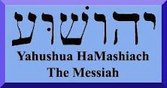Name of the **Messiah, Yahushua**, written in **Paleo Hebrew:**